A sample template for manuscript submission to Sulaimani Dent J (Delete this line)
Manuscript Title …………….
Abstract
Objectives: The present study aimed to investigate the oral health …………………………

Methods: A self-assessment questionnaire was used in this study and ……………………..

Results: ……………………………………………

Conclusions: ……………………………………….

Keywords: keyword1, keyword2, keyword3, keyword4, ……………..

Manuscript Title
Introduction:
Dental college students are expected to be educators of oral hygiene as well as role models of self-care procedures for their patients ¹. Text text text ^{1–4}.

Materials and methods:
Text text text

Results:
Text text etc ……. as shown in Table 1.

Discussion:
And text text text ⁶.

Conclusions:
Based on the results of this study, noticeable differences in the ……………
Ethics Approval
This study was conducted in accordance with the principles of the Declaration of Helsinki. Ethical approval was obtained from [name of institutional review board/ethics committee], with approval number [XXXX] dated [DD/MM/YYYY].
Clinical Trial Registration
This study was registered at [registry name, e.g., ClinicalTrials.gov] with registration number [XXX]. If not applicable (e.g., in vitro study): “Not applicable.”
Informed Consent
Written informed consent was obtained from all participants (or their legal guardians) prior to inclusion in the study. If not applicable (e.g., in vitro study): “Not applicable.”
Data Availability Statement
The data that support the findings of this study are available from the corresponding author upon reasonable request. Or: The datasets generated and/or analyzed during the current study are available in [repository name, link].
Author Contributions (Refere to: ICMJE recommendations )
Conceptualization, S.J.H and A.B.C; methodology, S.J.H.; software, A.B.C.; validation, A.B.C., S.J.H. and A.J.N.; formal analysis, S.J.H.; investigation, S.J.H.; resources, F.A.K. and A.J.N.; data curation, S.J.H.; writing—original draft preparation, S.J.H.; writing—review and editing, S.J.H. and K.J.N.; visualization, S.J.H.; supervision, A.J.N. ; project administration, A.B.C. and K.J.N.; Funding acquisition, ….. . All authors have read and agreed to the published version of the manuscript.
Funding
This research was supported by [funding agency name, grant number]. If no funding: “This research received no external funding.”
Conflicts of Interest
The authors declare that they have no conflicts of interest related to this study.
Or [Provide full disclosure of any financial or personal relationships that could influence the work.]
Acknowledgments
The authors appreciate the cooperation of their colleagues and the staff of the College of xxxxxxx at the University of xxxxxxxxx, and they extend their deepest gratitude to xxxx xxxxxxx and the institute of science ………. . If no acknowledgement is available; None.

References: (This template contains the reference style for this journal when used with the Zotero software)
1. Jaramillo JA, Jaramillo F, Kador I, Masuoka D, Tong L, Ahn C, et al. A comparative study of oral health attitudes and behavior using the Hiroshima University-Dental Behavioral Inventory (HU-DBI) between dental and civil engineering students in Colombia. J Oral Sci. 2013;55(1):23–8.
2. Freeman R. The psychology of dental patient care. 5. The determinants of dental health attitudes and behaviours. Br Dent J. 1999;187(1):15–8.
3. Cortes FJ, Nevot C, Ramon JM, Cuenca E. The evolution of dental health in dental students at the University of Barcelona. J Dent Educ. 2002;66(10):1203–8.
4. Folayan MO, Khami MR, Folaranmi N, Popoola BO, Sofola OO, Ligali TO, et al. Determinants of preventive oral health behaviour among senior dental students in Nigeria. BMC Oral Health. 2013;13(1):28.
5. Halawany HS, Abraham NB, Jacob V, Al-Maflehi N. The perceived concepts of oral health attitudes and behaviors of dental students from four Asian countries. Saudi J Dent Res. The Saudi Journal for Dental Research; 2015;6(2):79–85.
6. Cavaillon JP, Conge M, Mirisch D, Nemeth T, Sitbon JM. Longitudinal study on oral health of dental students at Paris VII University. Community Dent Oral Epidemiol. 1982;10(3):137–43.

Examples of tables and figure: Placed after the referencs section

Table 1: Distribution of the participated students according to sex, class of study and level of study.
Class and level of study | Sex (n, %) |  | Total (n, %)
Class and level of study | Male | Female | Total (n, %)
1 | 23 (46) | 33 (37) | 56 (40)
2 | 5 (10) | 18 (20) | 23 (16)
Preclinical | 28 (56) | 51 (57) | 79 (56)
3 | 13 (26) | 20 (22) | 33 (24)
4 | 4 (8) | 11 (12) | 15 (11)
5 | 5 (10) | 8 (9) | 13 (9)
Clinical | 22 (44) | 39 (43) | 61 (44)
Total | 50 (36) | 90 (64) | 140 (100)

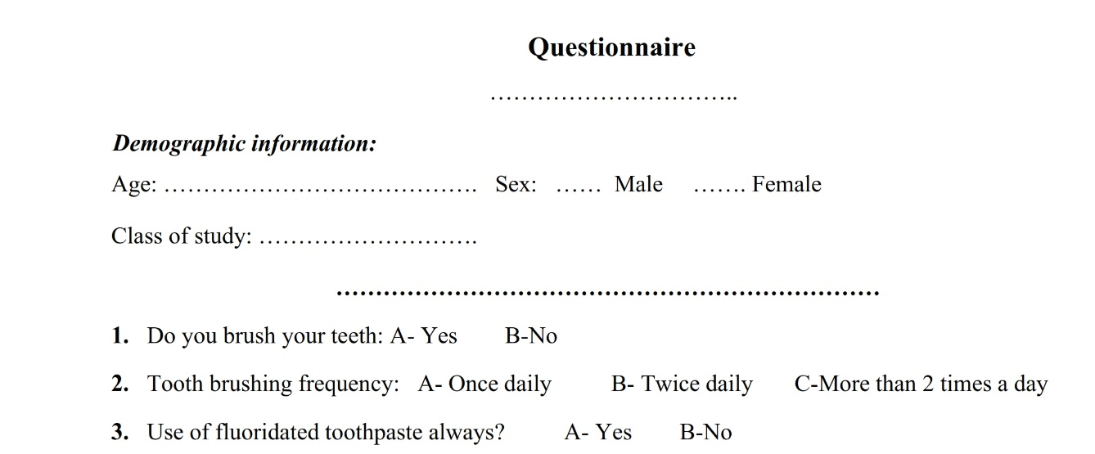

Figure 1: Questionnaire used in this study.

