A sample template for manuscript submission to Sulaimani Dent J (Delete this line)
Manuscript Title …………….
Abstract
Objectives: The present study aimed to investigate the oral health …………………………

Methods: A self-assessment questionnaire was used in this study and ……………………..

Results: ……………………………………………

Conclusions: ……………………………………….

Keywords: keyword1, keyword2, keyword3, keyword4, ……………..

Manuscript Title
Introduction:
Dental college students are expected to be educators of oral hygiene as well as role models of self-care procedures for their patients ¹. Text text text ^{1–4}.

Materials and methods:
Text text text

Results:
Text text etc ……. as shown in Table 1.

Discussion:
And text text text ⁶.

Conclusions:
Based on the results of this study, noticeable differences in the ……………
Clinical Relevance
…………….. ……………… Maximum 100 words.
Acknowledgments (optional)
The authors appreciate the cooperation of their colleagues and the staff of the College of xxxxxxx at the University of xxxxxxxxx, and they extend their deepest gratitude to xxxx xxxxxxx and the institute of science ………. .
Ethics Approval and Informed Consent (Institutional Review Board) Statement:
This research was approved by the Ethics Committee of the ………….. application No. xxx/xxx issued on xx/x/xxxxx. Informed consent statement ( informed consent was not applicable, although the patients approved using their extracted teeth for research purposes).
Author Contributions (Fill as appropriate)
Conceptualization, S.J.H and A.B.C; methodology, S.J.H.; software, S.J.H.; validation, A.B.C., S.J.H. and A.J.N.; formal analysis, S.J.H.; investigation, S.J.H.; resources, F.A.K. and A.J.N.; data curation, S.J.H.; writing—original draft preparation, S.J.H.; writing—review and editing, S.J.H. and K.J.N.; visualization, S.J.H.; supervision, …...; project administration, A.B.C. and K.J.N. All authors have read and agreed to the published version of the manuscript.
Conflicts of Interest:
The authors declare no conflict of interest.
Funding:
This research received no external funding. (Or received ………..)
Data Availability Statement:
The data that support the findings of this study are available from the corresponding author upon reasonable request. Or any other statement by the authors.
Artificial Intelligence and Generative AI Disclosure
The authors declare that no generative artificial intelligence (AI) tools were used in the preparation, writing, editing, analysis, or generation of this manuscript. Or [The authors used [name of AI tool] for language editing and/or improving the clarity of the manuscript. The authors reviewed and edited all AI-assisted content and take full responsibility for the accuracy, originality, and integrity of the final manuscript.]

References: (This template contains the reference style for this journal when used with the Zotero software)
1. Jaramillo JA, Jaramillo F, Kador I, Masuoka D, Tong L, Ahn C, et al. A comparative study of oral health attitudes and behavior using the Hiroshima University-Dental Behavioral Inventory (HU-DBI) between dental and civil engineering students in Colombia. J Oral Sci. 2013;55(1):23–8.
2. Freeman R. The psychology of dental patient care. 5. The determinants of dental health attitudes and behaviours. Br Dent J. 1999;187(1):15–8.
3. Cortes FJ, Nevot C, Ramon JM, Cuenca E. The evolution of dental health in dental students at the University of Barcelona. J Dent Educ. 2002;66(10):1203–8.
4. Folayan MO, Khami MR, Folaranmi N, Popoola BO, Sofola OO, Ligali TO, et al. Determinants of preventive oral health behaviour among senior dental students in Nigeria. BMC Oral Health. 2013;13(1):28.
5. Halawany HS, Abraham NB, Jacob V, Al-Maflehi N. The perceived concepts of oral health attitudes and behaviors of dental students from four Asian countries. Saudi J Dent Res. The Saudi Journal for Dental Research; 2015;6(2):79–85.
6. Cavaillon JP, Conge M, Mirisch D, Nemeth T, Sitbon JM. Longitudinal study on oral health of dental students at Paris VII University. Community Dent Oral Epidemiol. 1982;10(3):137–43.

Examples of tables and figure: Placed after the referencs section

Table 1: Distribution of the participated students according to sex, class of study and level of study.
Class and level of study | Sex (n, %) |  | Total (n, %)
Class and level of study | Male | Female | Total (n, %)
1 | 23 (46) | 33 (37) | 56 (40)
2 | 5 (10) | 18 (20) | 23 (16)
Preclinical | 28 (56) | 51 (57) | 79 (56)
3 | 13 (26) | 20 (22) | 33 (24)
4 | 4 (8) | 11 (12) | 15 (11)
5 | 5 (10) | 8 (9) | 13 (9)
Clinical | 22 (44) | 39 (43) | 61 (44)
Total | 50 (36) | 90 (64) | 140 (100)

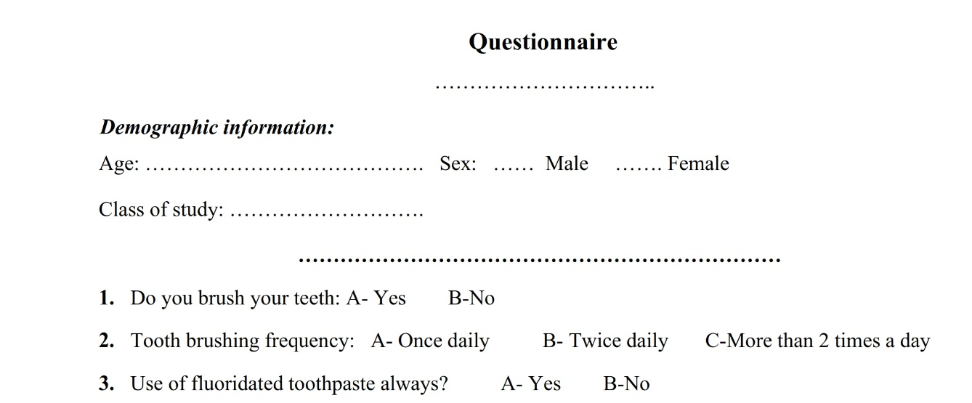

Figure 1: Questionnaire used in this study.

